**IMPLEMENTATION OF DRIVING SCHOOL MANAGEMENT SYSTEM**

**AIM:**

To design various forms and implement DRIVING SCHOOL MANAGEMENT SYSTEM using Visual Basic as front end and MS ACCESS as back end.

**OBJECTIVE:**

1. To learn form designing in VB and how to interconnect the various forms.
2. To know the usage of various tools supported by Visual Basic .
3. To learn ODBC connectivity to connect the form with the database.
4. To write code and implement operations like adding a record , viewing the records , updating a record , searching a record and deleting a specific record on the connected database.

**SOFTWARE REQUIRED :**

Microsoft Visual Basic 6.0 and MS Access.

**ABSTRACT:**

The main aim of the project is to design innovative software, which deals with the driving school management . The driving school management system project is developed in visual basic as front end and ms access as back end. This project is developed to manage the applicants details of both two-wheeler(mcwg) and four-wheeler(lmv). The 2-wheeler and 4-wheeler applicant details are added separately and user can search or modify the record whenever they desire by logging in with the correct username and password which they have given during registration. If they provide incorrect password they will not be able to search records .This project has an admin login system. The administrator will enter the username and password to login to the system. If  the username and password are correct, it will open the next form. If the entered details are not correct, it will show the error message. The administrator’s purpose is to delete records by entering the customer’s name , deleting records as they may have to remove data where the customer would have completed the course or have withdrawn. The delete admin-interface is separate for 2-wheeler and 4-wheeler.If record exists, the record will be deleted else it will display error message. The home page will also lead to forms wherein we can view about the driving school’s main motto and the driving school’s contact details and address .

**MODULE 1:**

Home page where in each command connects to various other forms .

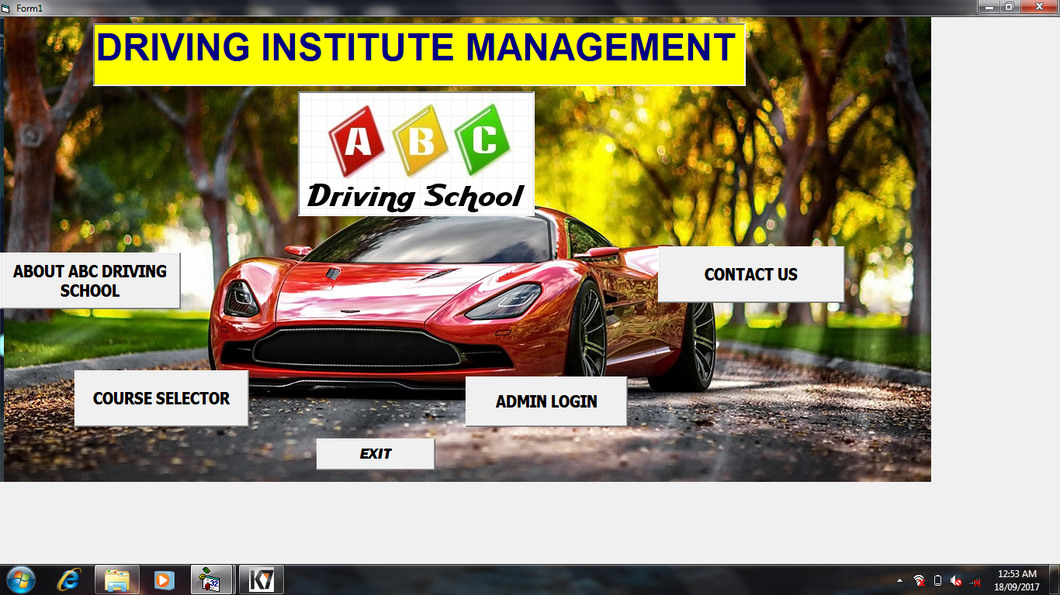

**FORM1 CODE:**

Private Sub Command1_Click()

Form2.Show

Form1.Hide

End Sub

Private Sub Command2_Click()

Form3.Show

Form1.Hide

End Sub

Private Sub Command3_Click()

Form7.Show

Form1.Hide

End Sub

Private Sub Command4_Click()

Form8.Show

Form1.Hide

End Sub

Private Sub Command5_Click()

End

End Sub

**MODULE 2:**

User interface window and This displays about the driving school and its motto and back button will lead back to the home page.

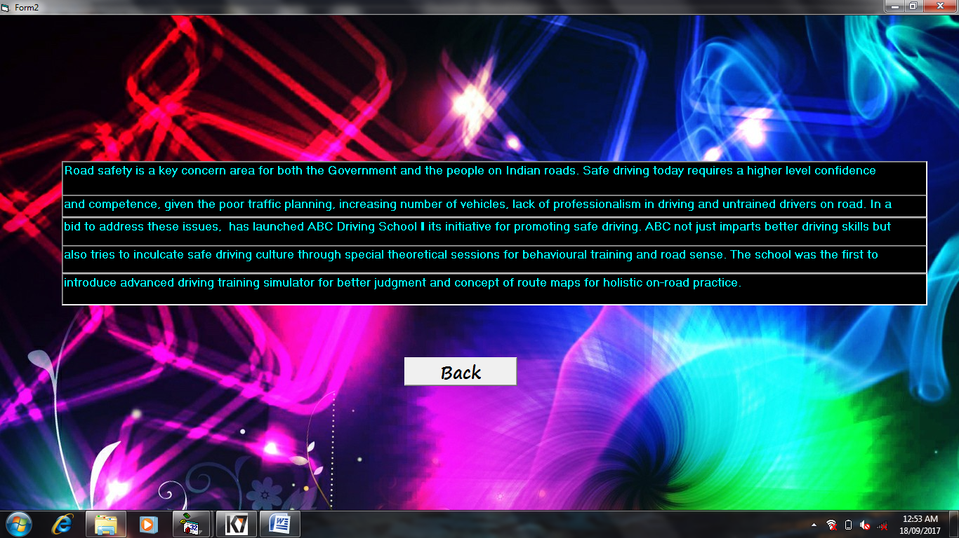

**FORM 2 CODE:**

Private Sub Command1_Click()

Form1.Show

Form2.Hide

End Sub

**MODULE 3:**

User interface window wherein the user can choose his course(course selector).

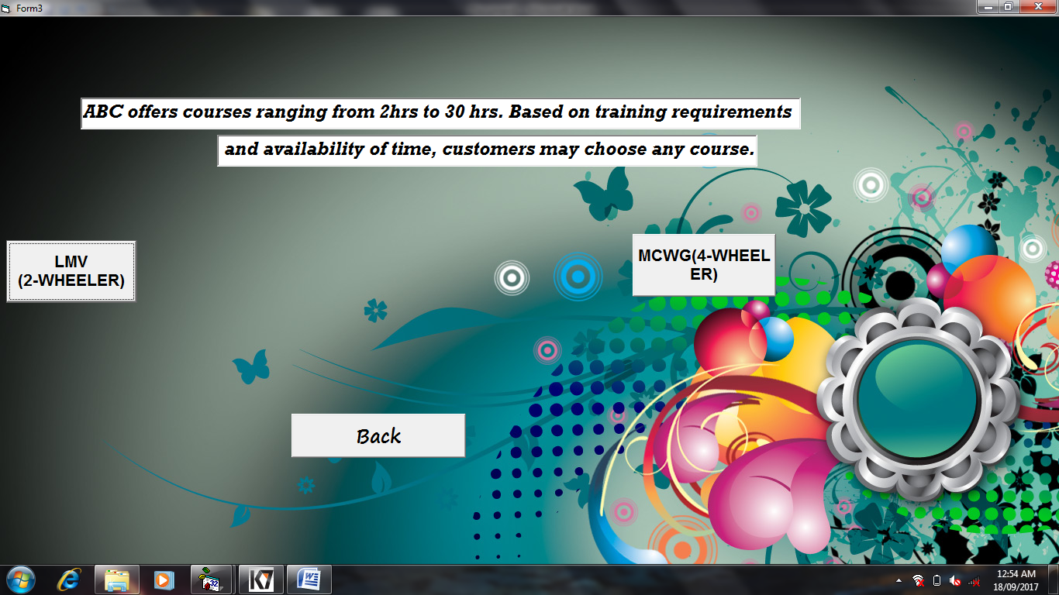

**FORM3 CODE:**

Private Sub Command1_Click()

Form4.Show

Form3.Hide

End Sub

Private Sub Command2_Click()

Form6.Show

Form3.Hide

End Sub

Private Sub Command3_Click()

Form1.Show

Form3.Hide

End Sub

**MODULE 4:**

User interface window which Displays training requirements and leads to registration form and the back option will lead back to the course selector window.

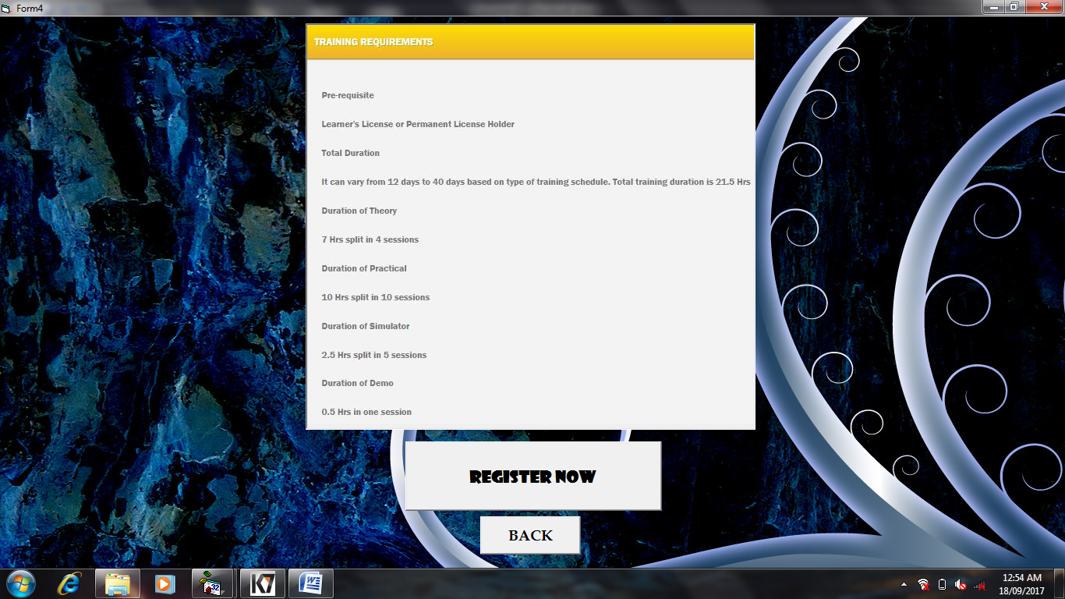

**FORM4 CODE:**

Private Sub Command1_Click()

Form5.Show

Form4.Hide

End Sub

Private Sub Command2_Click()

Form3.Show

Form4.Hide

End Sub

**MODULE 5:**

User registration window for 2-wheeler which can also search, update record.

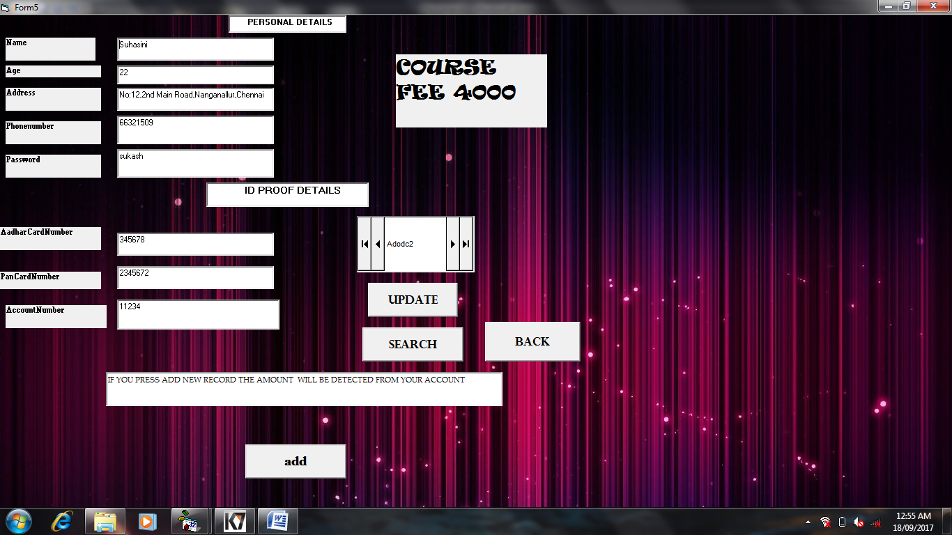

**FORM5 CODE:**

Private Sub Command1_Click()

Adodc2.Recordset.Update

MsgBox "updated"

End Sub

Private Sub Command2_Click()

Adodc2.Recordset.AddNew

MsgBox "registered"

End Sub

Private Sub Command3_Click()

Form4.Show

Form5.Hide

End Sub

Private Sub S_Click()

i = InputBox("ENTER THE CUSTOMER PASSWORD")

Adodc2.Recordset.MoveFirst

Do Until Adodc2.Recordset.EOF = True

If Text5.Text = i Then

Exit Sub

Else

Adodc2.Recordset.MoveNext

End If

Loop

MsgBox ("incorrect password")

End Sub

**MODULE 6:**

User registration window for 4-wheeler which can also search, update record.

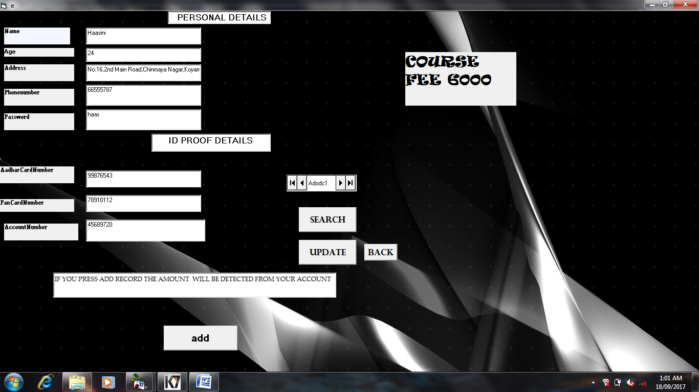

**FORM6 CODE:**

Private Sub Command1_Click()

Adodc1.Recordset.Update

MsgBox "updated"

End Sub

Private Sub Command2_Click()

Adodc1.Recordset.AddNew

MsgBox "registered"

End Sub

Private Sub Command3_Click()

i = InputBox("ENTER THE CUSTOMER PASSWORD")

Adodc1.Recordset.MoveFirst

Do Until Adodc1.Recordset.EOF = True

If Text5.Text = i Then

Exit Sub

Else

Adodc1.Recordset.MoveNext

End If

Loop

MsgBox ("incorrect password")

End Sub

Private Sub Command4_Click()

Form4.Show

Form6.Hide

End Sub

**MODULE 7:**

Admin login.

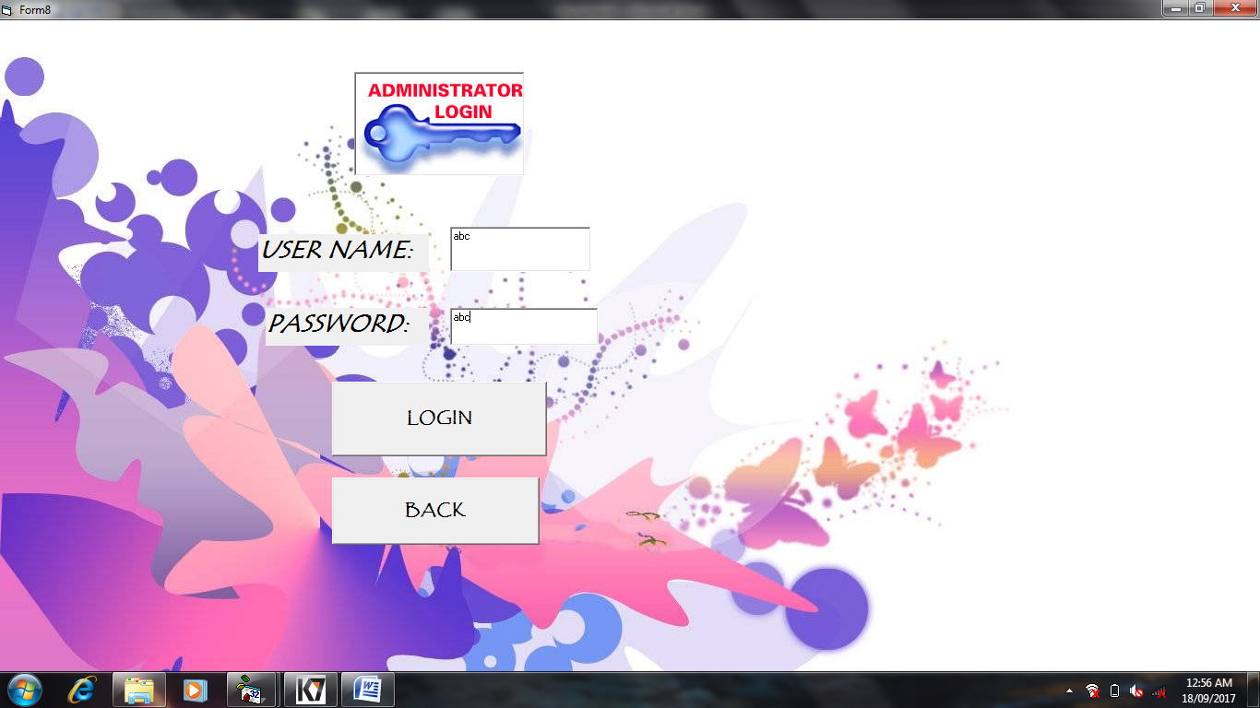

**FORM8 CODE:**

Private Sub Command1_Click()

If Text1.Text = "abc" And Text2.Text = "abc" Then

MsgBox "the password you entered is correct"

Form9.Show

Form8.Hide

Else

MsgBox "YOUR LOGIN IS DENIED"

End If

End Sub

Private Sub Command2_Click()

Form1.Show

Form8.Hide

End Sub

**MODULE 8:**

Admin interface where in the admin can delete particular records of both 2-wheeler and 4-wheeler applicants. Records are deleted on the basis of customer name. Back will lead back to admin login.

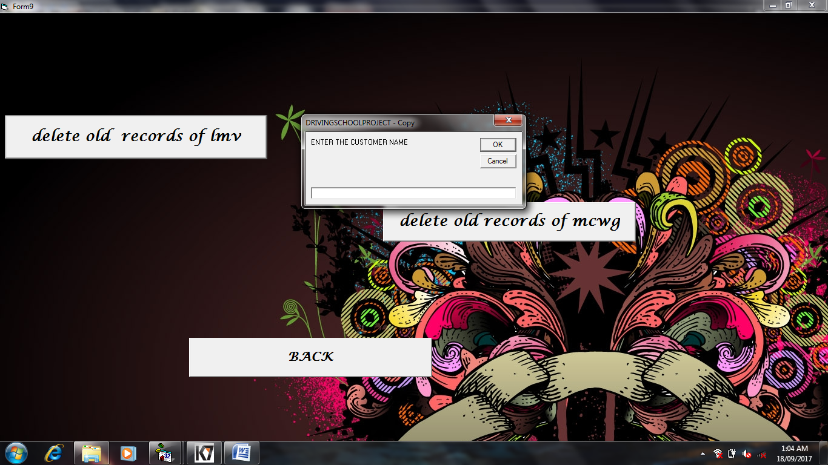

**FORM9 CODE:**

Private Sub Command1_Click()

i = InputBox("ENTER THE CUSTOMER NAME")

Form5.Adodc2.Recordset.MoveFirst

Do Until Form5.Adodc2.Recordset.EOF = True

If Form5.Text1.Text = i Then

Form5.Adodc2.Recordset.Delete

MsgBox "record deleted"

Exit Sub

Else

Form5.Adodc2.Recordset.MoveNext

End If

Loop

MsgBox ("NO RECORD FOUND")

End Sub

Private Sub Command2_Click()

Form8.Show

Form9.Hide

End Sub

Private Sub Command3_Click()

i = InputBox("ENTER THE CUSTOMER NAME")

Form6.Adodc1.Recordset.MoveFirst

Do Until Form6.Adodc1.Recordset.EOF = True

If Form6.Text1.Text = i Then

Form6.Adodc1.Recordset.Delete

MsgBox "record deleted"

Exit Sub

Else

Form6.Adodc1.Recordset.MoveNext

End If

Loop

MsgBox ("NO RECORD FOUND")

End Sub

**MODULE 9:**

Displays driving school contact details and back will lead bact to the home page.

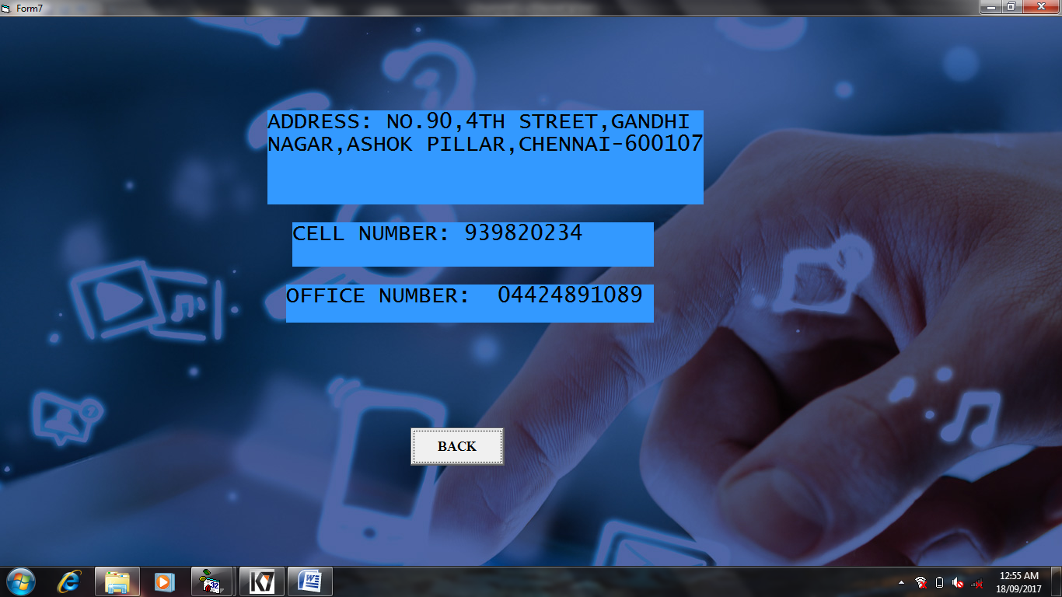

**FORM7 CODE:**

Private Sub Command1_Click()

Form1.Show

Form7.Hide

End Sub

**RESULT:**

The implementation of DRIVING SCHOOL MANAGEMENT SYSTEM is successfully executed using Visual Basic and MS Access.